Learners have to come up with a Report to support the answers to the following questions and suggestions

Objective Questions
- Are there any tables with duplicate or missing null values? If so, how would you handle them?
Ans: No, there are no duplicate or missing null values.

Query - - -
SELECT id, comment_text,user_id,photo_id,created_at, COUNT(*) AS count_duplicates
FROM comments
GROUP BY id, comment_text,user_id,photo_id,created_at
HAVING COUNT(*) > 1

SELECT *
FROM comments
WHERE id IS NULL
OR comment_text IS NULL
OR user_id IS NULL
OR photo_id IS NULL
OR created_at IS NULL

SELECT follower_id, followee_id,created_at, count(*) as duplicate_count
from follows
group by follower_id, followee_id,created_at
having count(*) > 1;

SELECT * FROM follows
where follower_id is null
or followee_id is null
or created_at is null

SELECT user_id, photo_id,created_at, count(*) as duplicate_count
from likes
group by user_id, photo_id,created_at
having count(*) > 1

select * from likes
where user_id is null
or photo_id is null
or created_at is null

select photo_id, tag_id, count(*) as duplicate_count
from photo_tags
group by photo_id, tag_id
having count(*) > 1

select * from photo_tags
where photo_id is null
OR tag_id is null

select id,image_url,user_id,created_dat, count(*) as duplicate_count
from photos
group by id,image_url,user_id,created_dat
having count(*) > 1

select * from photos
where id is null
or image_url is null
or user_id is null
or created_dat is null

select id, tag_name, created_at,count(*) as duplicate_count
from tags
group by id, tag_name, created_at
having count(*) > 1

select * from tags
where id is null
or tag_name is null
or created_at is null

select id, username, created_at, count(*) as duplicate_count
from users
group by id, username, created_at
having count(*) > 1

SELECT * FROM users
where id is null
or username is null
or created_at is null
- What is the distribution of user activity levels (e.g., number of posts, likes, comments) across the user base?
Ans:
No of photos posted per user
Query - - -
WITH n_posts_count as (
SELECT user_id, count(*) as post_count
from photos
group by user_id
)
SELECT COALESCE(post_count,0) as post_count,
COUNT(*) AS n_of_users
from users u
left join n_posts_count npc
on u.id = npc.user_id
group by COALESCE(post_count,0)
order by post_count
Output - - -
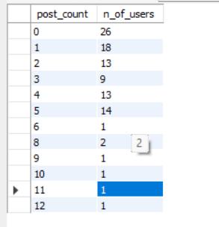
Analysis - - -

No of likes count per user -
Query - - -
WITH N_OF_LIKES AS (SELECT user_id , count(*) as no_of_likes
from likes
group by user_id
)
SELECT COALESCE(no_of_likes,0) as Number_of_likes,
COUNT(*) as no_of_users
from users u
left join N_OF_LIKES NOL
on u.id = NOL.user_id
GROUP BY COALESCE(no_of_likes,0)
ORDER BY Number_of_likes
Result - - -
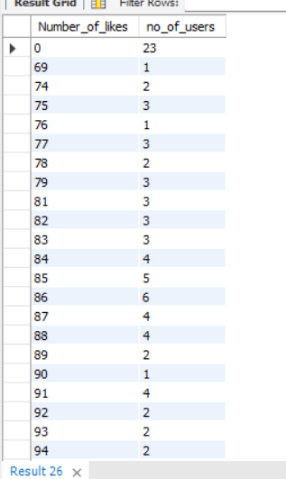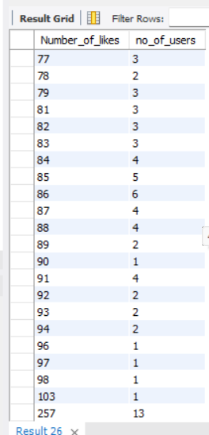
Analysis - - -

Comment count per user -
Query - - -
WITH comment_counts AS (
SELECT user_id, COUNT(*) AS comment_count
FROM comments
GROUP BY user_id
)
SELECT
COALESCE(comment_count, 0) AS comment_count,
COUNT(*) AS user_count
FROM users u
LEFT JOIN comment_counts c
ON u.id = c.user_id
GROUP BY COALESCE(comment_count, 0)
ORDER BY comment_count;
Result - - -
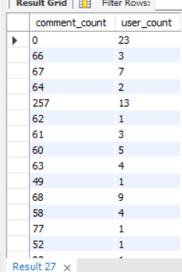

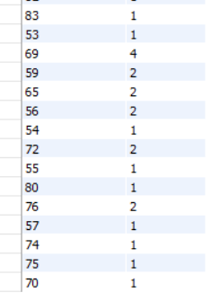
Analysis - - -
- Calculate the average number of tags per post (photo_tags and photos tables).
Ans:
Query - - -
WITH Tag_Counts as (
SELECT p.id as photo_id,
count(pt.tag_id) as C_OF_Tag
from photos p
LEFT join photo_tags pt
on p.id = pt.photo_id
group by p.id
)
SELECT AVG(C_OF_Tag) avg_tags_per_post
from Tag_Counts

Result - - -
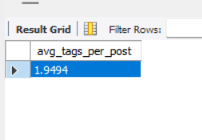
- Identify the top users with the highest engagement rates (likes, comments) on their posts and rank them.
Ans:
Query - - -
WITH n_of_likes as (
SELECT photo_id, count(*) as n_of_like
from likes
group by photo_id
),
n_of_comments as (
SELECT photo_id, count(*) as n_of_comment
from comments
group by photo_id
),
photo_engagements as (
SELECT p.user_id,
p.id,
COALESCE(l.n_of_like,0) as n_of_like,
COALESCE(c.n_of_comment,0) as n_of_comment,
COALESCE(l.n_of_like,0) + COALESCE(c.n_of_comment,0)
as engagement_score
from photos p
left join n_of_likes l
on p.id = l.photo_id
left join n_of_comments c
on p.id = c.photo_id
),
user_engagement as (
SELECT user_id,
SUM(engagement_score) as overall_engagement
from photo_engagements
group by user_id
)
SELECT u.id,
u.username,
ue.overall_engagement,
RANK() over(order by ue.overall_engagement desc) as Rank_eng
from user_engagement ue
join users u
on ue.user_id = u.id
order by ue.overall_engagement desc

Result - - -
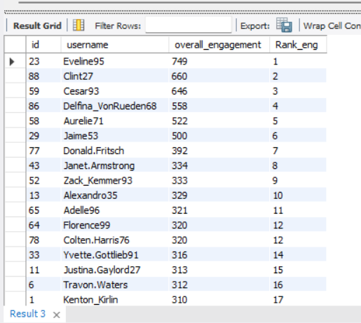
- Which users have the highest number of followers and followings?
Ans:
Query - - -
WITH no_of_followers as (
SELECT followee_id as user_id, count(*) as no_of_follower
from follows
group by followee_id
),
no_of_followings as (
SELECT follower_id as user_id, count(*) as no_of_following
from follows
group by follower_id
),
All_counts as (
SELECT u.id,
u.username,
COALESCE(fw.no_of_follower,0) as no_of_follower,
COALESCE(fe.no_of_following,0) as no_of_following
from users u
left join no_of_followings fe
on u.id = fe.user_id
left join no_of_followers fw
on u.id = fw.user_id
)
SELECT
* , RANK() over(order by no_of_follower desc) as highest_followers,
RANK() over(order by no_of_following desc) as highest_following
from All_counts
order by highest_followers,highest_following

Result - - -
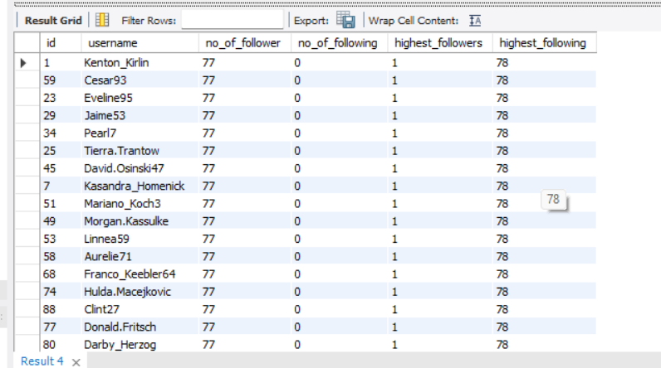
- Calculate the average engagement rate (likes, comments) per post for each user.
Ans -
Query – - -

WITH n_of_likes as (
SELECT photo_id, count(*) as n_of_like
from likes
group by photo_id
),
n_of_comments as (
SELECT photo_id, count(*) as n_of_comment
from comments
group by photo_id
),
photo_engagement as (
SELECT p.user_id,
p.id,
COALESCE(l.n_of_like,0) as n_of_like,
COALESCE(c.n_of_comment,0) as n_of_comment,
COALESCE(l.n_of_like,0) + COALESCE(c.n_of_comment,0)
as engagement
from photos p
left join n_of_likes l
on p.id = l.photo_id
left join n_of_comments c
on p.id = c.photo_id
)
SELECT u.id,
u.username,
avg(pe.engagement) as avg_engagement_per_post
from users u
left join photo_engagement pe
on u.id = pe.user_id
group by u.id, u.username
order by avg_engagement_per_post desc

Result - - -
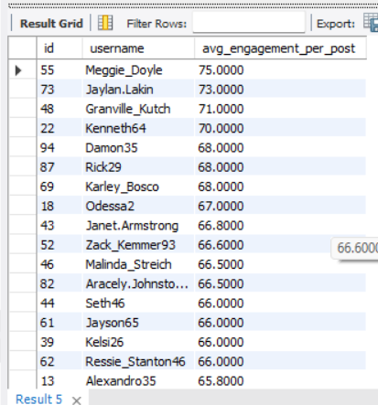
- Get the list of users who have never liked any post (users and likes tables)

Ans:
Query - - -
SELECT u.id, u.username
from users u
left join likes l
on l.user_id = u.id
where l.user_id is null
Result - - -
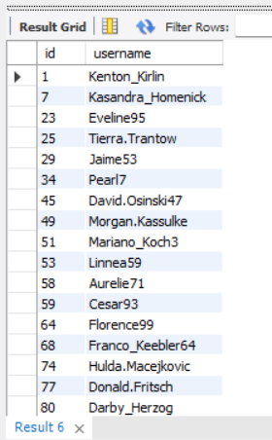
- How can you leverage user-generated content (posts, hashtags, photo tags) to create more personalized and engaging ad campaigns?

Ans:
Query - - -
WITH no_of_likes as (
SELECT photo_id, count(*) as no_of_like
from likes
group by photo_id
),
no_of_comments as (
SELECT photo_id, count(*) as no_of_comment
from comments
group by photo_id
),
photo_engagement as (
SELECT p.user_id,
p.id,
COALESCE(l.no_of_like,0) as no_of_like,
COALESCE(c.no_of_comment,0) as no_of_comment,
COALESCE(l.no_of_like,0) + COALESCE(c.no_of_comment,0)
as engagement_score
from photos p
left join no_of_likes l
on p.id = l.photo_id
left join no_of_comments c
on p.id = c.photo_id
),
tag_engagement_rate as (
SELECT t.id,
t.tag_name,
COUNT(DISTINCT pt.photo_id) as no_of_photos,
SUM(pe.engagement_score) as total_engagements,
ROUND(SUM(pe.engagement_score) / COUNT(DISTINCT pt.photo_id),2)
as engagement_rate
from tags t
join photo_tags pt
on t.id = pt.tag_id
join photo_engagement pe
on pe.id = pt.photo_id
group by t.id,t.tag_name
)
SELECT * FROM tag_engagement_rate
order by engagement_rate desc, total_engagements desc
limit 3;

Result - - -
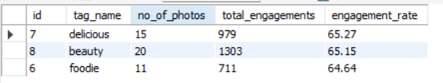
Analysis - - -

By analysing UGC engagement, we can identify the hashtags and content themes that users respond to most, such as
#delicious,
#beauty,
and
#foodie.
These themes can then be reused in paid social ads, lookalike campaigns, and retargeting creatives to make the ads feel more relevant, authentic, and trustworthy.
With Permission-based reposting of user photos and tags can improve social proof, engagement, and click-through rates.
- Are there any correlations between user activity levels and specific content types (e.g., photos, videos, reels)? How can this information guide content creation and curation strategies?

Ans:
Query - - -
WITH no_of_likes as (
SELECT photo_id, count(*) as no_of_like
from likes
group by photo_id
),
no_of_comments as (
SELECT photo_id, count(*) as no_of_comment
from comments
group by photo_id
),
no_of_photo_tags as (
SELECT photo_id, count(*) as no_of_photo_tag
from photo_tags
group by photo_id
),
engagement_scores as (
SELECT p.user_id,
p.id,
COALESCE(l.no_of_like,0) as no_of_like,
COALESCE(c.no_of_comment,0) as no_of_comment,
COALESCE(pt.no_of_photo_tag,0) as no_of_photo_tag,
COALESCE(l.no_of_like,0) + COALESCE(c.no_of_comment,0) +
COALESCE(pt.no_of_photo_tag,0)
as engagement_score
from photos p
left join no_of_photo_tags pt
on p.id = pt.photo_id
left join no_of_likes l
on p.id = l.photo_id
left join no_of_comments c
on p.id = c.photo_id
)
SELECT u.id,
u.username,
COALESCE(sum(ES.no_of_like),0) as total_no_of_like,
COALESCE(sum(ES.no_of_comment),0) as total_no_comment,
COALESCE(sum(ES.no_of_photo_tag),0) as total_no_of_photo_tag,
COALESCE(sum(ES.engagement_score),0) as total_engagement_score
from users u
left join engagement_scores ES
on u.id = ES.user_id
group by u.id, u.username
order by u.id

Output - - -
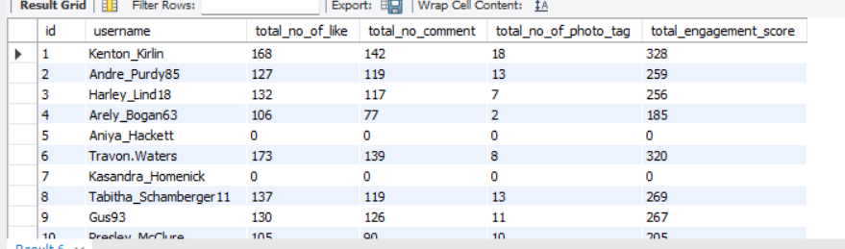
Analysis - - -

1.This is photo-content correlation analysis
2. I created user-level metrics for likes, comments, tags, and
engagement score.
This helps test whether higher activity is associated with stronger photo engagement.
Content Creation -
I will use these engagement patterns to identify which themes, formats, or posting styles should be produced more often. For example, if some types of photo posts consistently get more likes and comments, then I will create more content in that style and test variations around it.
A simple strategy is -
- I will produce more of the content patterns with strong engagement score.
- Then I will curate and reshare top-performing user content.
- I will reduce focus on low-engagement patterns.
- I will keep testing new variations around the best-performing themes.
- Calculate the total number of likes, comments, and photo tags for each user.

Ans:
Query - - -
WITH no_of_likes as (
SELECT photo_id, count(*) as no_of_like
from likes
group by photo_id
),
no_of_comments as (
SELECT photo_id, count(*) as no_of_comment
from comments
group by photo_id
),
no_of_photo_tags as (
SELECT photo_id, count(*) as no_of_photo_tag
from photo_tags
group by photo_id
),
engagement_scores as (
SELECT p.user_id,
p.id,
COALESCE(l.no_of_like,0) as no_of_like,
COALESCE(c.no_of_comment,0) as no_of_comment,
COALESCE(pt.no_of_photo_tag,0) as no_of_photo_tag,
COALESCE(l.no_of_like,0) + COALESCE(c.no_of_comment,0) +
COALESCE(pt.no_of_photo_tag,0)
as engagement_score
from photos p
left join no_of_photo_tags pt
on p.id = pt.photo_id
left join no_of_likes l
on p.id = l.photo_id
left join no_of_comments c
on p.id = c.photo_id
)
SELECT u.id,
u.username,
COALESCE(sum(ES.no_of_like),0) as total_no_of_like,
COALESCE(sum(ES.no_of_comment),0) as total_no_comment,
COALESCE(sum(ES.no_of_photo_tag),0) as total_no_of_photo_tag,
COALESCE(sum(ES.engagement_score),0) as total_engagement_score
from users u
left join engagement_scores ES
on u.id = ES.user_id
group by u.id, u.username
order by u.id

Result - - -
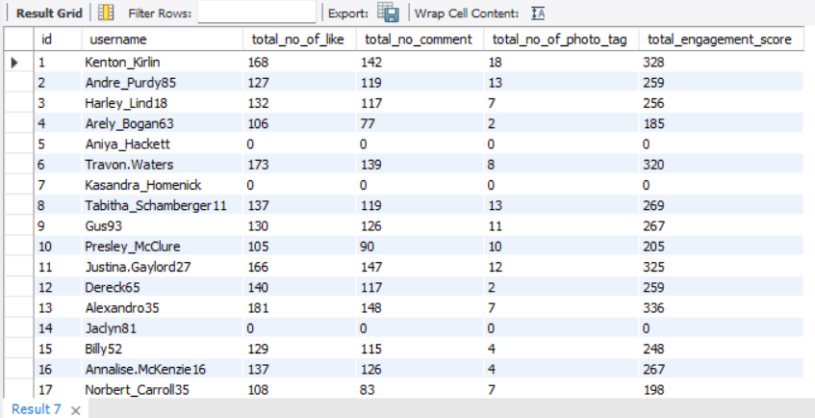

- Rank users based on their total engagement (likes, comments, shares) over a month.

Ans:

Query – - -

WITH no_of_likes as (
SELECT photo_id, count(*) as no_of_like
from likes
group by photo_id
),
no_of_comments as (
SELECT photo_id, count(*) as no_of_comment
from comments
group by photo_id
),
no_of_photo_tags as (
SELECT photo_id, count(*) as no_of_photo_tag
from photo_tags
group by photo_id
),
engagement_scores as (
SELECT p.user_id,
p.id,
COALESCE(l.no_of_like,0) as no_of_like,
COALESCE(c.no_of_comment,0) as no_of_comment,
COALESCE(pt.no_of_photo_tag,0) as no_of_photo_tag,
COALESCE(l.no_of_like,0) + COALESCE(c.no_of_comment,0) +
COALESCE(pt.no_of_photo_tag,0)
as engagement_score
from photos p
left join no_of_photo_tags pt
on p.id = pt.photo_id
left join no_of_likes l
on p.id = l.photo_id
left join no_of_comments c
on p.id = c.photo_id
),
total_engagement_scores as (
SELECT u.id,
u.username,
COALESCE(sum(ES.no_of_like),0) as total_no_of_like,
COALESCE(sum(ES.no_of_comment),0) as total_no_comment,
COALESCE(sum(ES.no_of_photo_tag),0) as total_no_of_photo_tag,
COALESCE(sum(ES.engagement_score),0) as total_engagement_score
from users u
left join engagement_scores ES
on u.id = ES.user_id
group by u.id, u.username
order by u.id
)
SELECT *,
RANK() over(order by total_engagement_score desc) as Rnk_total_engagement_scores
from total_engagement_scores
Output - - -
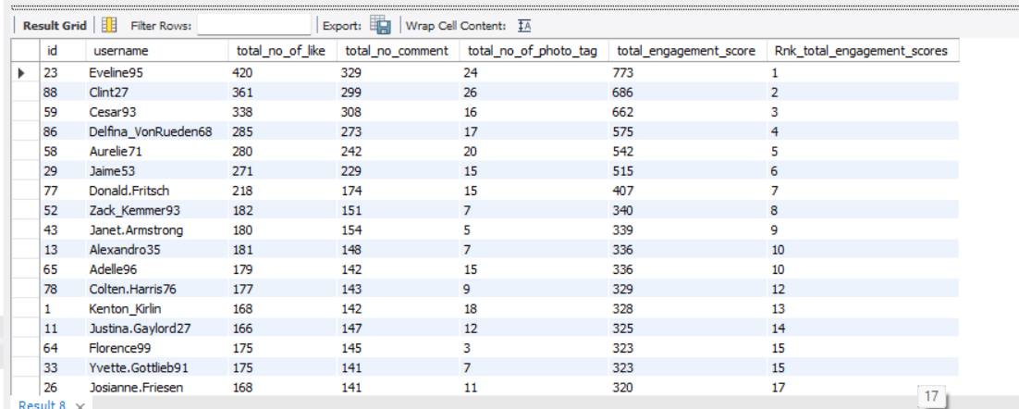

- Retrieve the hashtags that have been used in posts with the highest average number of likes. Use a CTE to calculate the average likes for each hashtag first.

Ans:

Query – - -

WITH likes_count as (
SELECT photo_id,
count(*) as no_of_like
from likes
group by photo_id
),
avg_like_hashtag as (
SELECT t.tag_name,
COALESCE(avg(l.no_of_like),0) as avg_of_likes
from tags t
join photo_tags pt
on t.id = pt.tag_id
join photos p
on pt.photo_id = p.id
left join likes_count l
on p.id = l.photo_id
group by t.tag_name
)
SELECT *
FROM avg_like_hashtag alh
where avg_of_likes = (
SELECT MAX(avg_of_likes)
from avg_like_hashtag
)

Output - - -
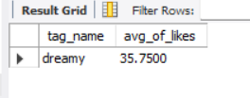

- Retrieve the users who have started following someone after being followed by that person
Ans:
Query - - -
SELECT DISTINCT f1.follower_id
from follows f1
join follows f2
on f1.follower_id = f2.followee_id
and f1.followee_id = f2.follower_id
where f1.created_at = f2.created_at
Output - - -
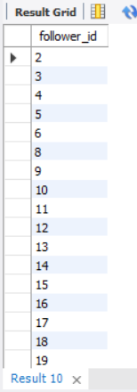

Subjective Questions
- Based on user engagement and activity levels, which users would you consider the most loyal or valuable? How would you reward or incentivize these users?

Ans:
Id : 23 , username : 'Eveline95'
Id : 88, username : 'Clint27'
are the most loyal users as per the total engagement scores that
they had.

Output - - -

Common ways to reward loyal or valuable users include:

- Personalized offers or discounts.

- Early access to new content or products.

- VIP tiers or exclusive membership benefits.

- Surprise gifts, badges, or recognition.

- Referral rewards or points systems.

- For inactive users, what strategies would you recommend to re-engage them and encourage them to start posting or engaging again?

Ans:
Query - - -
SELECT u.id, u.username,
COUNT(DISTINCT l.photo_id) AS no_of_likes,
COUNT(DISTINCT c.photo_id) AS no_of_comments,
COUNT(DISTINCT pt.photo_id) AS no_of_photo_tags
FROM users u
LEFT JOIN likes l
ON l.user_id = u.id
LEFT JOIN comments c
ON c.user_id = u.id
LEFT JOIN photos p
ON p.user_id = u.id
LEFT JOIN photo_tags pt
ON pt.photo_id = p.id
WHERE l.user_id IS NULL
AND c.user_id IS NULL
AND pt.photo_id IS NULL
GROUP BY u.id, u.username;
Output - - -
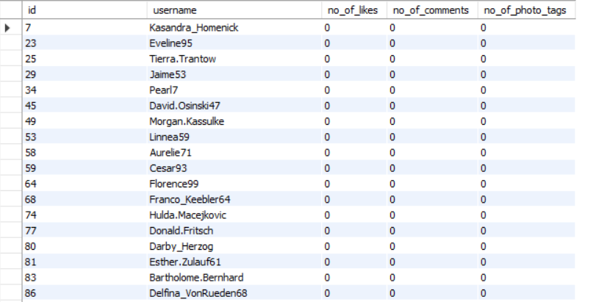
Analysis - - -
Re-engagement strategies - - -

I will Send a personalized nudge based on what they previously viewed or followed.

By Using gentle incentives such as streaks, badges, or complete your profile reminders.

Recommend creators, topics, or communities similar to their interests.

Encouraging posting - - -
Giving them a low-effort posting template, such as share your day.

Prompting them with seasonal or challenge-based content ideas with rewards.

By Showing examples of posts from similar users to make posting feel more approachable.

Reducing the number of steps needed to create and publish a post.

- Which hashtags or content topics have the highest engagement rates? How can this information guide content strategy and ad campaigns?

Ans :
Query - - -
WITH no_of_likes as (
SELECT photo_id, count(*) as no_of_like
from likes
group by photo_id
),
no_of_comments as (
SELECT photo_id, count(*) as no_of_comment
from comments
group by photo_id
),
photo_engagement as (
SELECT p.user_id,
p.id,
COALESCE(l.no_of_like,0) as no_of_like,
COALESCE(c.no_of_comment,0) as no_of_comment,
COALESCE(l.no_of_like,0) + COALESCE(c.no_of_comment,0)
as engagement_score
from photos p
left join no_of_likes l
on p.id = l.photo_id
left join no_of_comments c
on p.id = c.photo_id
),
tag_engagement_rate as (
SELECT t.id,
t.tag_name,
COUNT(DISTINCT pt.photo_id) as no_of_photos,
SUM(pe.engagement_score) as total_engagements,
ROUND(SUM(pe.engagement_score) / COUNT(DISTINCT pt.photo_id),2)
as engagement_rate
from tags t
join photo_tags pt
on t.id = pt.tag_id
join photo_engagement pe
on pe.id = pt.photo_id
group by t.id,t.tag_name
)
SELECT * FROM tag_engagement_rate
where engagement_rate = (
SELECT MAX(engagement_rate) AS highest_engagement_rate
from tag_engagement_rate
ORDER BY engagement_rate desc
)

Output - - -
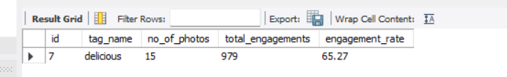

Analysis - - -

The top hashtags or topics show what our audience likes most. We can use them to plan more of the right content and to build ad campaigns around themes that already have high engagement.
- Are there any patterns or trends in user engagement based on demographics (age, location, gender) or posting times? How can these insights inform targeted marketing campaigns?

Ans: There is no data to find the patterns in user engagement based on
demographics (age, location, gender) or posting times.
Yes, engagement patterns often vary by age, gender, location,
and posting time. By analysing those segments, we can identify
the most responsive audience groups and use that insight to
schedule posts, tailor content, and target ads more effectively.

- Based on follower counts and engagement rates, which users would be ideal candidates for influencer marketing campaigns? How would you approach and collaborate with these influencers?

Ans:
Query - - -
WITH no_of_likes as (
SELECT photo_id, count(*) as no_of_like
from likes
group by photo_id
),
no_of_comments as (
SELECT photo_id, count(*) as no_of_comment
from comments
group by photo_id
),
photo_engagement as (
SELECT p.user_id,
p.id,
COALESCE(l.no_of_like,0) as no_of_like,
COALESCE(c.no_of_comment,0) as no_of_comment,
COALESCE(l.no_of_like,0) + COALESCE(c.no_of_comment,0)
as engagement_score
from photos p
left join no_of_likes l
on p.id = l.photo_id
left join no_of_comments c
on p.id = c.photo_id
),
user_engagement as (
SELECT pe.user_id,
COUNT(pe.id) as photo_count,
SUM(pe.engagement_score) as total_engagement,
SUM(pe.engagement_score) / COUNT(pe.id) as avg_eng_per_post
from photo_engagement pe
group by pe.user_id
),
Follower_count as (
SELECT followee_id as user_id,
COUNT(DISTINCT follower_id) as no_of_following
from follows
group by followee_id
)
SELECT u.id,
u.username,
COALESCE(ue.photo_count,0) AS photo_count,
COALESCE(ue.total_engagement,0) AS total_engagement,
COALESCE(ue.avg_eng_per_post,0) AS avg_eng_per_post,
COALESCE(fc.no_of_following,0) AS no_of_following,
RANK() over(order by fc.no_of_following desc, ue.avg_eng_per_post desc)
as Influencer_ranking
from users u
left join user_engagement ue
on u.id = ue.user_id
left join Follower_count fc
on u.id = fc.user_id
I would choose users with a good follower count, strong engagement rate.
I feel these are top ideal candidates for influencer marketing campaigns:

Output - - -
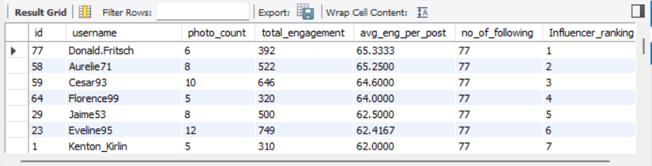
Then I’d approach them personally,
1. I will Start engaging naturally with their content.
2. Then I will send a short-personalized message that mentions why they
are a good fit.
3. By proposing a clear collaboration such as a
sponsored post,
giveaway,
ambassador partnership.
- Based on user behavior and engagement data, how would you segment the user base for targeted marketing campaigns or personalized recommendations?

Ans:
I would segment the user base by,
1. total likes/comments/posts.

2. average engagement per post.

3. For which hashtag they have a high engagement.
Then I would use each segment for personalized recommendations and targeted campaigns, such as re-engagement for inactive users, rewards for loyal users, and tailored content for highly active users.
Example: -
users with high engagement rate and many followers = good for influencer-style campaigns.
users with low engagement but recent activity = good for re-engagement campaigns.
- If data on ad campaigns (impressions, clicks, conversions) is available, how would you measure their effectiveness and optimize future campaigns?

Ans: I would measure ad effectiveness using CTR, conversion rate, and
CPA.

CTR = clicks / impressions.

Conversion rate = conversions / clicks.

Impression-to-conversion rate = conversions / impressions.

CPA = spend / conversions

I can improve future campaigns by:

- Testing multiple ad creatives and headlines.

- Narrowing or expanding audiences based on performance.

- shifting budget to high-converting campaigns.

- and stopping underperforming ads early.

- How can you use user activity data to identify potential brand ambassadors or advocates who could help promote Instagram's initiatives or events?

Ans: I can use user activity data to find people who already behave
like natural advocates: users who post often, comment positively,
mention the brand, share tagged content, and drive engagement
from others.

According to me the best candidates are not just popular, they are
also:
- authentic,
- aligned with the brand,
- active in relevant conversations,
- and likely to create content that feels natural to their audience.

I would like to identify ambassadors by tracking
engagement, reach, hashtags, mentions, and UGC, then reaching
out with a tailored message and clear collaboration plan.

- How would you approach this problem, if the objective and subjective questions weren't given?

Ans: If the objective and subjective questions were not given,
1. I would start by identifying the business goal first,
2. Then choose the most useful metrics and segmentation logic
from the available tables based on what each one represents.

3. By Identifying the key entities like ex in this case: users, photos,
likes, comments, tags, and follows.

4. Looking for patterns in engagement such as top users, active
users, popular tags, and highest followers.

5. Converting those patterns into business questions like retention,
influencer identification, or content optimization.

- Assuming there's a "User_Interactions" table tracking user engagements, how can you update the "Engagement_Type" column to change all instances of "Like" to "Heart" to align with Instagram's terminology?
Ans:

Query - - -
UPDATE User_Interactions
SET Engagement_Type = 'Heart'
WHERE Engagement_Type = 'Like'
Lectures Drive link : https://drive.google.com/drive/folders/1i7o3tiIeVFuL0z_8EkDeiAsufDmn7KT1

